Sprint 2 Plan

Flsh

10/23/17

Release 0.0

Sprint 2 Plan

**Goal:**

The goal of sprint 2 is to make Google Maps API work so that a user can see the map.

**User Stories:**

US1: As a user, I want to be able to see my location on the map.

Task 1: Google Maps working (6)

Task 2: read and write to database (3)

Total for user story: 9 hours

US2: As a user, I want to navigate the map.

Task 1: Continue to familiarize ourselves with the Google Maps API. (2)

Task 2: Implement a basic map into the app (4)

Total for user story: 6 hours

US3: As a user, I want to be able to log into the app using google/facebook authentication in order to login.

Task 1: Use firebase to set up user authentication (4)

Total for user story: 4 hours

US4: As a user, I want to interact with the UI.

Task 1: Design the basic layout of the app when it starts up (6)

**Team Roles:**

Jessica Del Rio Product Owner, Developer

Emily Bettencourt   Developer

Sabrina Leano Developer

Oliver Ma 2nd Scrum Master, Developer

**Initial Task assignment**

Jessica Del Rio US1: Task 1, US2: Task 1, Task 2

Emily Bettencourt   US1: Task 2, US3: Task 1

Sabrina Leano US1:Task 1, U2: Task 1, Task 2

Oliver Ma US4: Task 1

**Initial Burn up chart**

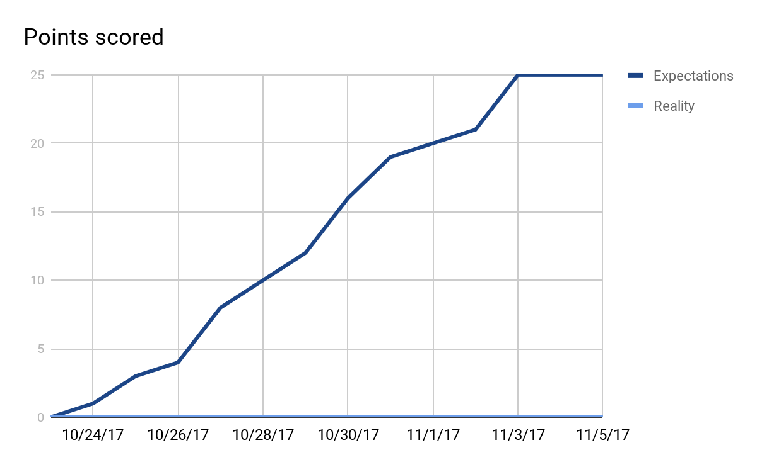

**Initial Scrum Board**

<http://scrumblr.ca/Flsh>

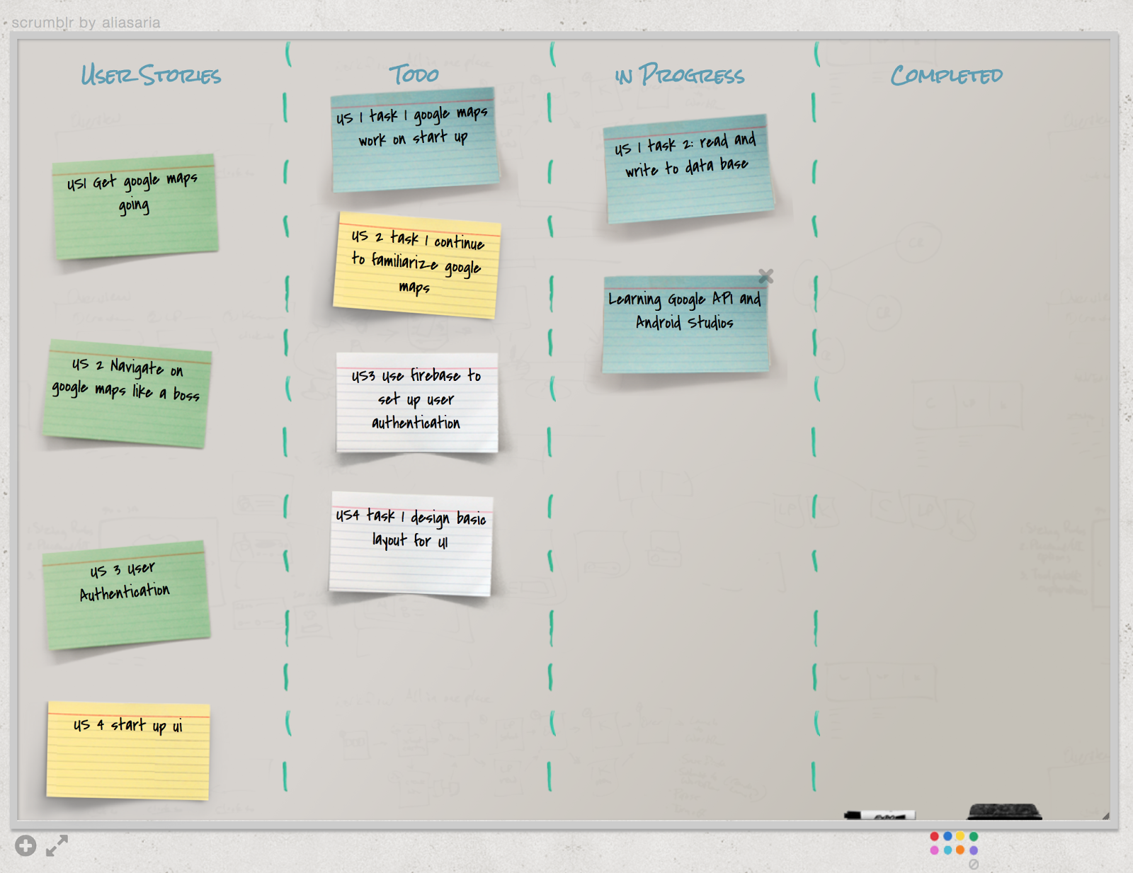

**Scrum Times**

Mon: 11am

Tues: 3:30pm

Thurs: 4:40-5pm